**SHRIRAM** **COLLEGE** **OF** **EDUCATION** **RAJNANDGAON**

**LIBRARY** **BOOK’S** **DETAILS**

|  |  |
| --- | --- |
| **TOTAL** **NO** **OF** **BOOK’S** | **3963** |
| **TOTAL** **NO** **OF** **JOURNAL’S** | **1** **INTERNATIONAL** **&** **11** **NATIONAL** **LEVEL** |
| **TOTAL** **NO** **OF** **MAGZINS** | **8** |
| **TOTAL** **NO** **OF** **NEWS** **PAPER** **IN** **HINDI** | **4** |
| **TOTAL** **NO** **OF** **NEWS** **PAPER** **IN** **ENGLISH** | **2** |

**USEFUL** **HYPERLINK** **FOR** **STUDENTS**

https://ncte.gov.in/website/WRC http://scert.cg.gov.in https://www.durguniversity.ac.in

**COLLEGE** **BUILDING**

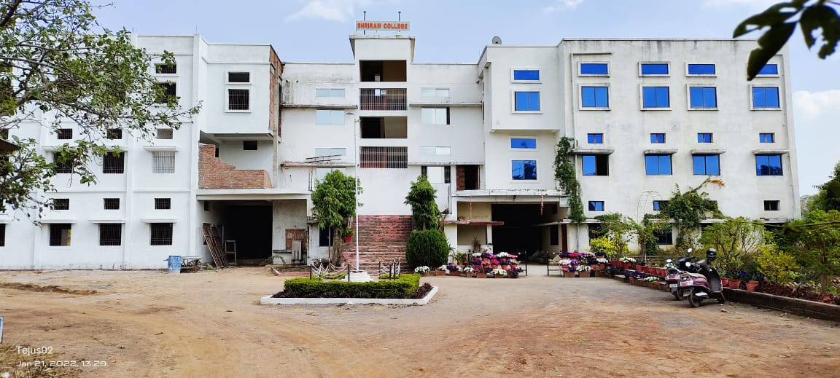

**E.T.** & **COMPUTER LAB.**

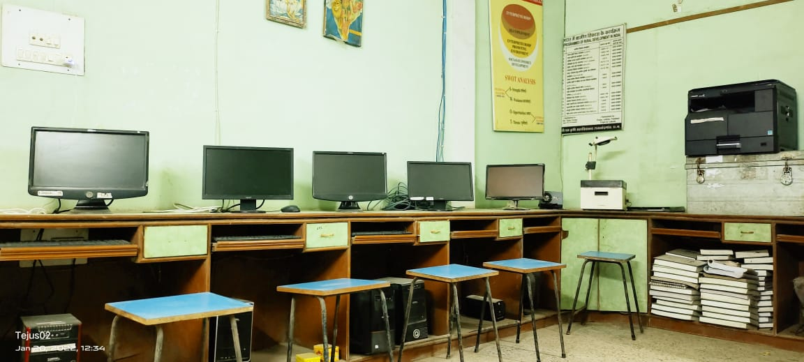

**PSYCHOLOGY** **LAB.**

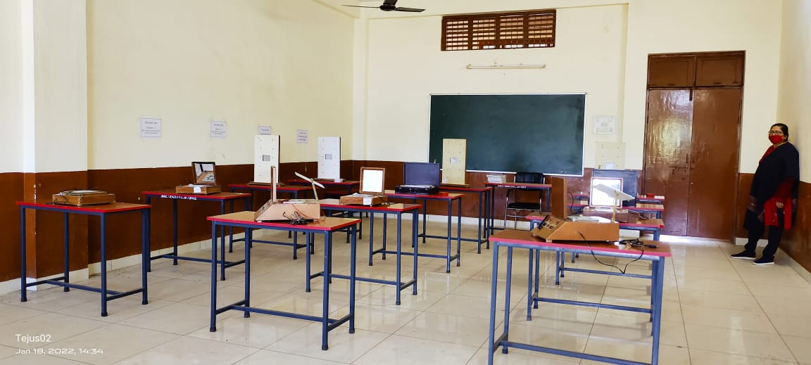

**SCIENCE** **LAB.**

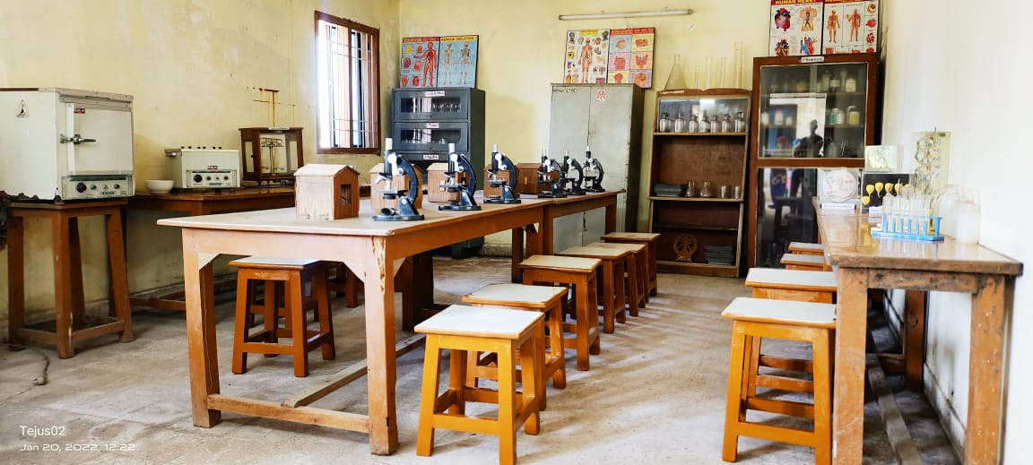

**MULTIPURPOSE** **HALL**

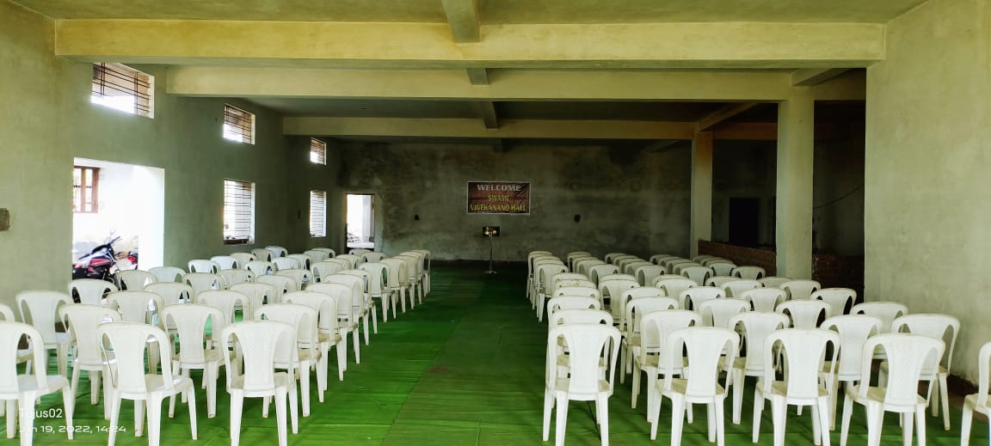

**SEMINAR** **HALL**

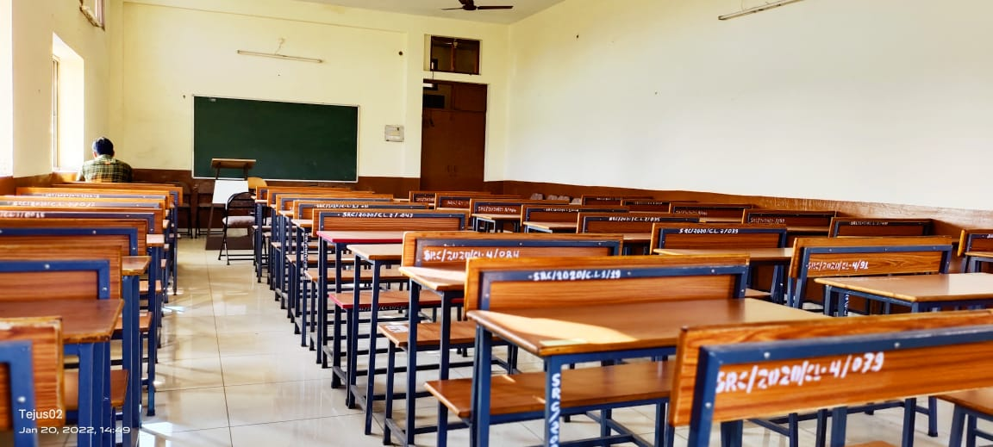

**CLASS** **ROOM**

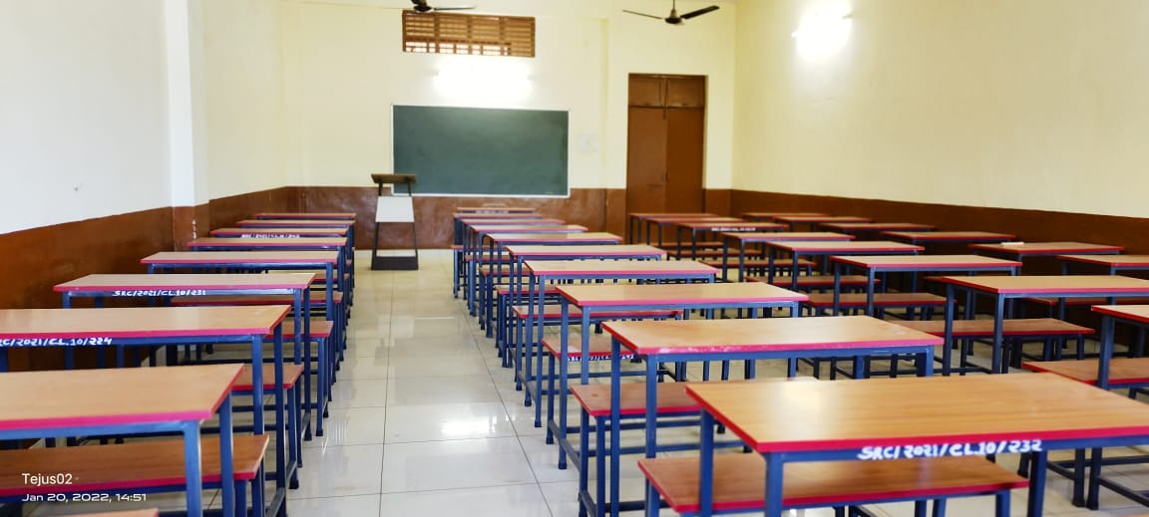

**BUS** **FACILITY**

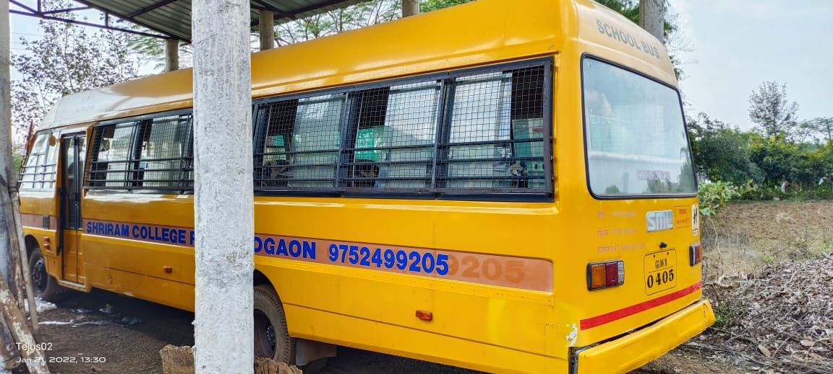

**CANTEEN**

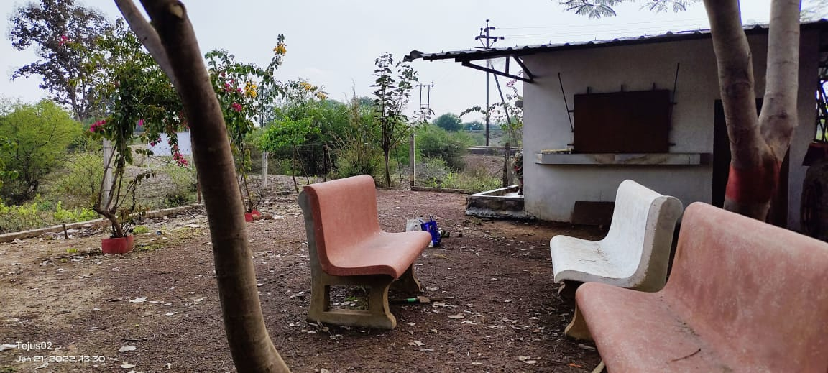

**PARKING** **ZONE**

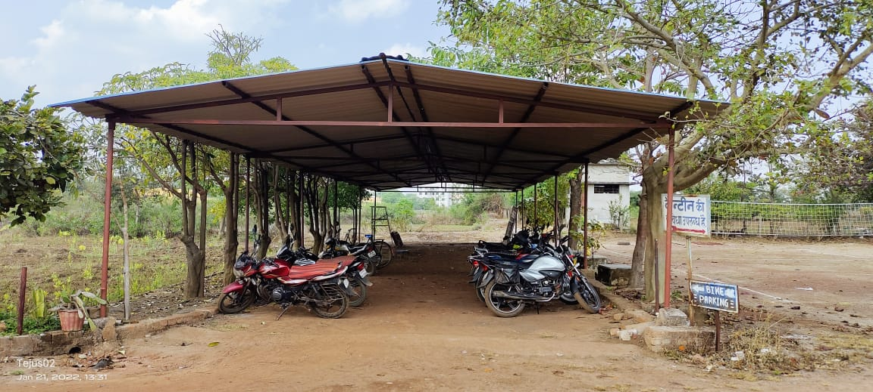

**PLAY** **GROUND**

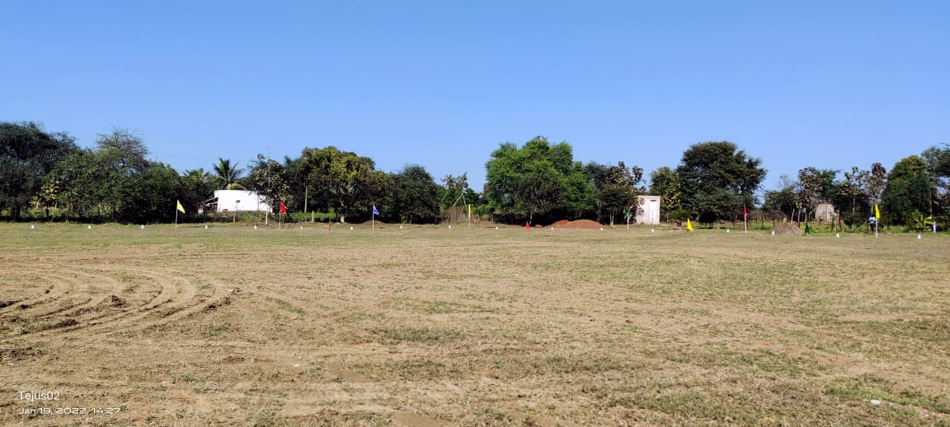

**O2** **ZONE**

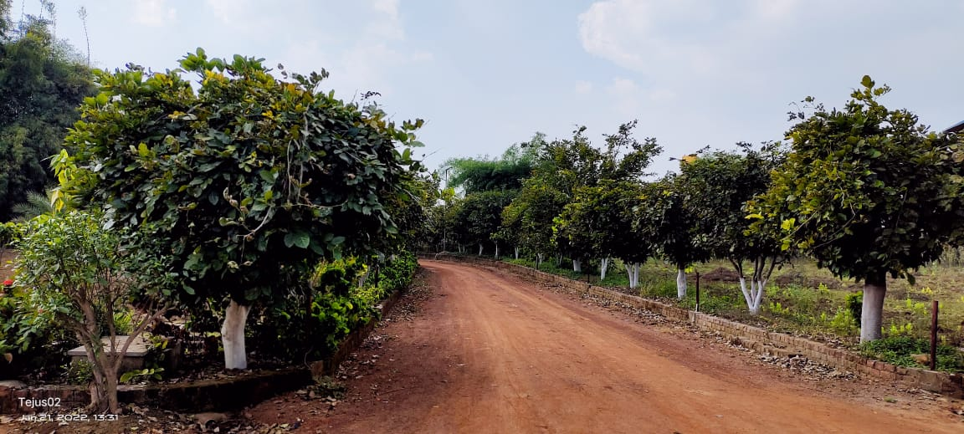

**INFRASTRUCTURE** **DETAIL’S**

|  |  |  |
| --- | --- | --- |
| **S.NO.** | **NAME** | **SIZE(Sq.mt.)** |
| **01** | **Class** **Room** | **65.06** |
| **02** | **Multipurpose** **Hall** | **301.08** |
| **03** | **Seminar** **Hall** | **111.52** |
| **04** | **Science** **Lab-1** | **65.06** |
| **05** | **Science** **Lab-2** | **65.06** |
| **06** | **Psychology** **lab.** | **25.49** |
| **07** | **E.T.** **&** **Computer** **Lab.** | **25.49** |
| **08** | **Library** **with** **Reading** **Room** | **111.52** |
| **09** | **Boys** **Common** **Room** | **65.06** |
| **10** | **Girls** **Common** **Room** | **24.16** |
| **11** | **Principal** **Room** | **25.49** |
| **12** | **Office** | **13.65** |
| **13** | **Staff** **Room** | **25.49** |
| **14** | **Play** **Ground** |  |
| **15** | **Canteen** | **12.04** |